**SPECIFIC LEARNING DISABILITY**  
According to the federal register (34 CFR 300© 10) a Specific Learning Disability means a disorder in one or more of the basic psychological processes involved in understanding or in using language, spoken or written, that may manifest itself in an imperfect ability to listen, think, speak, read, write, spell, or do mathematics calculations, including conditions such as perceptual disabilities, brain injury, minimal brain dysfunction dyslexia, and developmental aphasia. It does not include learning problems that are primarily the result of visual, hearing, or motor disabilities, of intellectual disability, or emotional disability, or of an environmental, cultural, or economic disadvantage.

In order to determine if a student meets the criteria for a specific learning disability a multitude of data sources, including a pattern of strengths and weaknesses utilizing the Dual Discrepancy/Consistency (DD/C) operational definition of SLD, were applied. There are six diagnostic markers for the presence of a Specific Learning Disability condition, and the following were used to guide the process of determining a specific learning disability based on the presence of these markers.

**1. Presence of a normative academic deficit:**

* Put standard score(s) from achievement test that were deemed deficit(s)
* Other supporting data such as STAAR/REN 360, grades, data from supplemental interventions, etc.

*{EXAMPLE}*

XXX has had great difficulty meeting expectations on district, campus and state assessments as evidenced by her performance data above. On the KTEA-3, results showed that XXX obtained a Standard Score of 73 on the Decoding Composite and he/she obtained a Standard Score of 80 on the Math Computation subtest. Further, he/she has a history of inconsistent academic performance throughout his/her schooling. REN360 data also corroborates these concerns along with RTI progress monitoring data.

**2. Presence of a cognitive processing deficit:**

* Name the cognitive weaknesses
* Reference that these weaknesses create the Inhibiting Cognitive Composite (ICC) which represents an aggregate of processing weaknesses

*{EXAMPLE}*

XXX has specific weaknesses in Gc, and Gs. These are combined to create the Inhibiting Cognitive Composite (ICC) which is 61 and represents an aggregate of processing weaknesses.

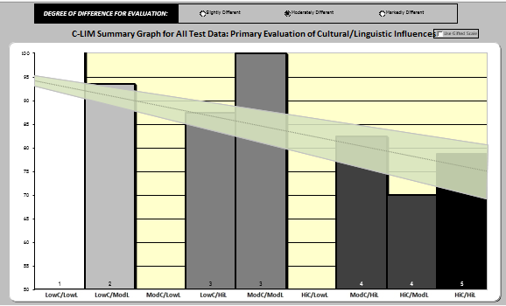

**If C-LIM involved: Provide summary on findings an include bar graph

**IMPORTANT** Snip/Use the SECOND graph, this is the one titled “C-LIM Summary Graph for All Test Data: Primary Evaluation of Cultural/Linguistic Influences”

**3. Profile within normal limits:**

* Name the intact cognitive abilities
* Reference that these abilities create the Facilitating Cognitive Composite (FCC) and how the student does have average ability.

{EXAMPLE},

XXX has intact cognitive abilities in Gf, Gv, Gsm, and Glr. These are combined to create the Facilitating Cognitive Composite (FCC), which is 93. Therefore, xxx does have average ability to learn when the attenuating aspects of his profile are removed.

{EXAMPLE} – If **NOT** in normal limits, need to include the bar graph/g-value image from XBASS

According to the data provided, there are multiple weaknesses in cognitive ability domains that are important for acquiring the academic skills typical for this grade level. *n’s overall cognitive ability is not likely to be in the average range of functioning and, therefore, learning will be challenging, as ability weaknesses constrain learning and achievement.

As a result, STUDENT’s academic difficulties may be attributed to global learning difficulties that are related to her cognitive functioning, rather than a specific learning disability.

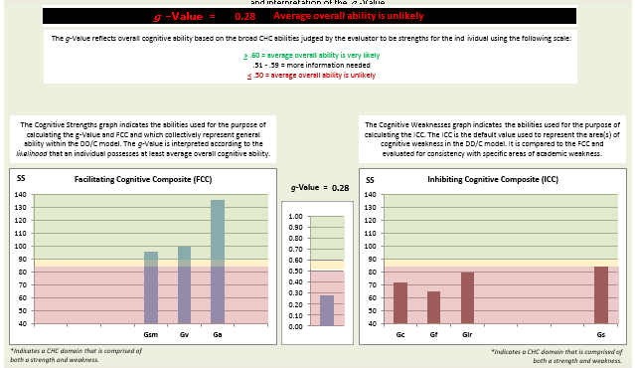

Given the data presented STUDENT does not meet TEA criteria as a student with a specific learning disability in the areas of Reading or Math.

**4. Empirical Relationship between cognitive and academic deficits:**

* Indicate the deficit G directly impacts the deficit achievement area

*{EXAMPLE}*

The deficit in Gc reflects difficult with the ability to understand relationships between words and understand meanings of individual words. In addition, poor processing speed impacts his ability to read accurately commensurate to same aged peers. Thus as he reads passages, he is likely to have difficulty processing the information (Gs) and integrating it with previously known information (Gc). Therefore, these deficits impact reading comprehension.

**5. Domain Specific cognitive weakness**:

{EXAMPLE}

The ICC *(or specific area of G being used in the bubbles such as Ga or Gsm*) is significantly lower than what would be expected based on STUDENT’S FCC. The difference between these scores indicates that the processing deficits are domain specific and not attributable to overall lower general ability.

**6**. **Unexpected academic underachievement**:

{EXAMPLE}

The score in reading comprehension is significantly below what would be expected based on the FCC

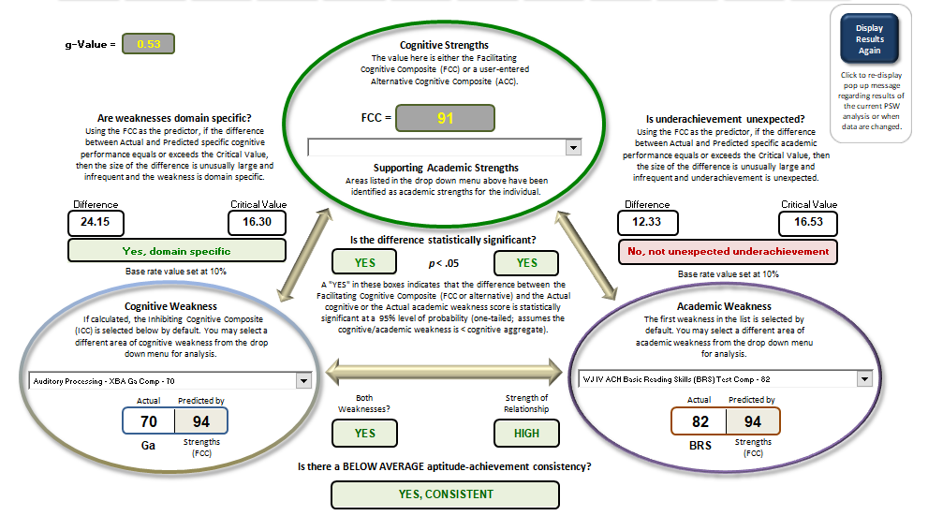

Given the data presented xxx **DOES/DOES NOT Meet** TEA criteria as a student with a specific learning disability in Reading Comprehension.

DYSLEXIA

Dyslexia is a specific learning disability that is neurological in origin. It is characterized by difficulties with accurate and/or fluent word recognition and by poor spelling and decoding abilities. These difficulties typically result from a deficit in the phonological component of language that is often unexpected in relation to other cognitive abilities and the provision of effective classroom instruction. Secondary consequences may include problems in reading comprehension and reduced reading experience that can impede the growth of vocabulary and background knowledge.          
  
Individuals with dyslexia have difficulty with processing and manipulating the sounds in a spoken language.  This is related to the ability to read words accurately and fluently.  Individuals with dyslexia will also have difficulty with spelling.  Some of the consequences of not reading accurately or fluently and thus having fewer reading experiences may include problems with reading comprehension and vocabulary.

**Then explain how this manifests for this child, and state if the DO/DO NOT meet the criteria

OTHER HEALTH IMPAIRMENT

According to the Texas Education Agency guidelines and the Individuals with Disabilities Education Act (IDEA 2004), a student may qualify for special education services as a student with *other health impairment*if:

The child has chronic or acute health problems: such as: asthma, **attention deficit disorder or attention deficit hyperactivity disorder**, diabetes, epilepsy, a heart condition, hemophilia, lead poisoning, leukemia, nephritis, rheumatic fever, sickle cell anemia, and Tourette syndrome. The health problems manifest themselves as: limited strength, limited vitality, or limited alertness; including a heightened alertness to environmental stimuli, that results in limited alertness with respect to the educational environment. The other health impairment adversely affects a child's educational performance; and by reason of the other health impairment, the child needs special education and related services. The multidisciplinary team must include information provided by a licensed physician, a physician assistant, or an advanced practice registered nurse with authority delegated under Texas Occupations Code, Chapter 157.

**Then explain how this manifests for this child, and state if the DO/DO NOT meet the criteria

Based on the information presented in this report, XXX  **DOES/DOES NOT**  meet eligibility criteria as a student with an Other Health Impairment.

*Example if recommending OHI but student doesn’t have a diagnosis yet or, we don’t have the Physician’s Report on file yet:*

However, STUDENT does not currently have a diagnosis of ADHD from a licensed physician on file with the district on the special education physicians’ report form. Should STUDENT’s behavior continue to interfere with HIS/HER educational performance despite the implementation of individualized academic supports and strategies, and a licensed physician provides documentation of a diagnosis of ADHD on an OHI Physician’s Report form that is submitted to the school, the examiner highly recommends that the ARD committee consider the eligibility of Other Health Impairment.

EMOTIONAL DISABILITY

According to the Texas Education Agency guidelines and the Individuals with Disabilities Education Act (IDEA 2004), a student may qualify for special education services as a student with an *Emotional Disability* if there is:

1. An inability to learn which cannot be explained by intellectual, sensory, or other health factors: XXX is reported to be mastering grade level academic skills without difficulty. XXX **does not meet** this criterion. ***OR*** Although XXX demonstrates academic difficulty, XXX is capable of learning. XXX **DOES NOT meet** this criterion.

2. An inability to build or maintain satisfactory relationships with peers and teachers: **Describe how and Provide examples how this manifests for the child. XXX **DOES/DOES NOT meet** this criterion.

3. Inappropriate types of behavior or feelings under normal circumstances: This criterion reflects behaviors which are unusual or infrequent in typically developing students. **Describe how and Provide examples how this manifests for the child. XXX **DOES/DOES NOT meet** this criterion.

4. A general pervasive mood of unhappiness or depression:

**Describe how and Provide examples how this manifests for the child. XXX **DOES/DOES NOT meet** this criterion.

5. A tendency to develop physical symptoms or fears associated with personal or school problems:

**Describe how and Provide examples how this manifests for the child. XXX **DOES/DOES NOT meet** this criterion.

It is concluded that XXX **DOES/DOES NOT MEET** the criteria for the condition of Emotional Disability.

AUTISM

Autism, as defined by Individuals with Disabilities Education Act (IDEA), refers to a developmental disability significantly affecting verbal and nonverbal communication and social interaction, generally evident before age three, that adversely affects a child’s educational performance. This federal definition then proceeds to name traits commonly related to the condition: Other characteristics often associated with autism are engaging in repetitive activities and stereotyped movements, resistance to environmental change or change in daily routines, and unusual responses to sensory experiences. The term autism does not apply if the child’s educational performance is adversely affected primarily because the child has an emotional disturbance, as defined in [IDEA].

**Describe how and Provide examples how this manifests for the child. (E.g., Verbal Communication, Nonverbal Communication, Socialization and Play, Sensory and Related Behaviors)

Therefore, it is concluded that HE/SHE **DOES NOT MEET** the Texas Education Agency (TEA) criteria for the disability condition of Autism.

INTELLECTUAL DISABILITY

According to the Texas Education Agency guidelines and the Individuals with Disabilities Education Act (IDEA 2004), a student may qualify for special education services as a student with *intellectual disability* if:  
  
1. The child demonstrates significantly subaverage general intellectual functioning in which the overall test score on a standardized, individually administered test of cognitive ability is at least two standard deviations below the mean, when taking into consideration the standard error of measurement of the test: **YES/NO** – **Describe how this manifests for this child.

2. The child demonstrates concurrent deficits in at least two of the following areas of adaptive behavior: communication, functional academic skills, health, use of community resources, home living, leisure, safety, work, self-care, self-direction, social/interpersonal skills: **YES/NO** – **Describe how this manifests for this child.

Based on the information presented in this report, STUDENT **DOES/DOES NOT** meet eligibility criteria as a student with an Intellectual Disability.

**DEVELOPMENTAL DELAY**

According to Texas Education Agency (TEA) guidelines, a student may qualify for special education as a student with Developmental Delay if they are between the ages of 3-9 and are evaluated by a multidisciplinary team for at least one disability category and whose evaluation data indicates a need for special education and related services and shows evidence of, but does not clearly confirm, the presence of the suspected disability or disabilities due to the child’s young age. In these cases, the ARD Committee may determine that data supports identification of developmental delay in one or more of the following areas: physical development, cognitive development, communication development, social or emotional development, or adaptive development. Multiple sources of data must converge to indicate the student has a developmental delay as described by one of the following:

1. Performance on appropriate norm-referenced measures, including developmental measures, indicate that the student is at least 2 standard deviations below the mean or at the 2nd percentile of performance, when taking into account the standard error of measurement (SEM), in one area of development as listed above;
2. Performance on appropriate norm-referenced measures, including developmental measures, indicate that the student is at least 1.5 standard deviations below the mean or at the 7th percentile of performance, when taking into account SEM, in at least two areas of development as listed above; OR
3. A body of evidence from multiple direct and indirect sources clearly documents a history and pattern of atypical development that is significantly impeding the student’s performance and progress across settings when compared to age-appropriate expectations and developmental milestones in one or more areas of development as listed above.